W-PHS Board Minutes

July 27, 2020 4pm-5:26pm
Reformed Church Pavilion

Call to Order-Nan Hance called the meeting to order at 4pm.

Roll Call of Officers and Standing Committee Chairs – Recording Secretary

Present: Nan Hance- President, Florence Doyle- Vice President, Jackie Walker- Recording Secretary, Linda Perkins-Corresponding Secretary, Sue Jane Evans- Exhibits Chair, Sandy Zeman-Communications Chair and Grants, Cheryl Kline-Nominating Chair

Absent: David Frohlich-Property Chair, Kathy McCaig-Membership Chair, Kathy Fedick-Cemetery Event Chair, Dottie Howland-Program Chair, Perry Howland-Ex Officio Trustee, Debbie Parts-Treasurer,

Reading/Acceptance of June 22nd Board Meeting Minutes – Recording Secretary. A motion was made by Linda, second by Sandy to accept the June 22, 2020 minutes as distributed. All in agreement.

Reading of Correspondence – Linda, Corresponding Secretary reported sympathy cards were sent to Hance, Garlock and Parts. Next Step: Send thank you note to Karen Manahan for use of Pavilion for meeting.

Reports of Officers

President - Nanette Hance circulated the following report:

ZOOM MEETINGS and WEBINARS (OTHER)
New York Adventures – City Island: New York’s Cape Cod
DPHSNY Webinars (2)

CON CALL
Golf Tournament 2021 (Tentative Date – Monday, June 7th, 2021)

PHONE CALLS
6 W-PHS Phone Calls which I either answered or referred to appropriate contacts

GRANTS
Reviewed another round of Pomeroy Grants with Sandy and determined not feasible.

NEWSLETTER
July/August newsletter President’s article
July/August member spotlight article/David Malgee

REOPENING SAFETY PLAN
Met with Sue Jane to discuss reopening.
Requested 4 Gallons of free NYS Hand Sanitizer; picked up in Geneva and delivered to W-PHS.
Reviewed suggested revisions from Dr. David Hannan and distributed to Board.
Made revisions to plan which reflect Dr. Hannan’s recommendations.
Revised plan to reflect most recent reopening capacity percentages (25% = 7.5 ppl) for W-PHS.
Solicited and received donations in the amount of $650 to cover cost of reopening dispensers and supplies.
Identified, ordered and received reopening dispenser equipment and gel sanitizer.
Wrote Thank You notes to three (3) donors for reopening donations.
Wrote Thank You note to Dr. Hannan for reviewing plan.
Wrote Thank You note to Senator Helming’s Office for hand sanitizer.
Assisted with finding space and moving Gift Shop Merchandise to hall closet.
Sent letter of Congratulations from W-PHS to Mary Grace Mazzulo as new Supt. Of Schools emphasizing our interest in continuing the Education Partnership we have built.

COLLECTION MANAGEMENT/ARCHIVES
Attended two (2) meetings with Archives to review draft plan presented by Florence. Rearranged storage room at top of stairs for recently acquired books from donor, Les Buell.

GATES HALL/GATESINGERS
Corresponded with new Pres. of Gatesinger Co. on 7/1 in regards to their 6/30 email concerns and our need for their reopening plan. No follow up on their part to schedule desired meeting.

(Next Step: send report to Jackie)

Vice President – Florence Doyle reported:

Nan Hance, myself and the members of the Collections Management Committee (Irene Bierer, Cheri Kline, Dan Montondo) have met twice to develop a DRAFT Collections Management Plan to guide us in our process to continuously improve and meet future needs of the Society and Community. Elements of the Plan include but are not limited to the following:

Participate in Conservation Center for Art & Historic Artifacts “INTRODUCTION DIGITIZATION 101 WEBINAR SERIES” - Six Modules

Review Existing Collections Management Policy/Procedure

Review Structure of Collections Management

Develop A W-PHS Acceptable Use Technology Policy

Determine Interim Steps to Begin (i.e. inventory data base) Without Creating Rework

Assessment and Benchmarking -
Explore and if appropriate schedule “Archival Needs Assessment” with DHPSNY
Explore and if appropriate schedule “Preservation Survey” with DHPSNY
Best practice similar organizations

Technology to Manage Collections

Digitization

(Next Step: send report to Jackie)

Treasurer – Debbie Parts reported the following by email:
Account balances reviewed. We received $650 from donors for use in getting Covid supplies. So far, we have spent $394.75 of this. Because Gates Hall has been closed, our RG&E bills have run a total of $346 less than last year from March to present, and $440 for the whole year. No other extraordinary expenses since last month. I did renew Landmark membership and revised budget as attached to the best of my ability.
Insurance news: This is just an update. Nan and I discussed and thought since I would not be in attendance that this can hold until next meeting.
I have received some information on Directors & Officers insurance from Tim Cappon. $882 for $1,000,000 coverage.
Still waiting on bonding insurance info from Tim Cappon. From our current supplier, this is the quote I received: For the position schedule coverage of the 3 positions noted, at $200,000 with a $1,500 deductible each, the 3-year premium is $789. Annually, $263. We currently pay $181 for a 3-year policy, treasurer only, $50,000 coverage, no deductible that I am aware of.
Recording Secretary – Jackie Walker. no report.

Corresponding Secretary – Linda Perkins. See above report under correspondence.

Ex-Officio Trustee- Perry Howland reported by email the following:
- Working with Williamson-Pultneyville Historical Society on a variety of outreaches:
- Assisted WPHS Program Chair with research and providing information about the history of newspapers in Williamson. Information has been posted on WPHS Facebook page in lieu of canceled May 6 program meeting on this topic.
- Met with WPHS Display Committee members Sue-Jane Evans and Amy McConville to share our thoughts and ideas relative to opening our facility to visitors. Ran through a mock visitor to the house to see if plans and procedures are in place for opening on August 2.
- Participated in Wayne Historians Organization (WHO) Zoom meetings on July 14 and 21.
- Have continued to create a listing of Williamson people, places, groups and other categories to submit to WHO members Loreen Jorgensen and Chris Davis, that will be used on a two-year Wayne County Bicentennial Calendar. Also looking for historic photos of Williamson to submit for the same project.
- On-going clipping of obituaries and other items from newspapers/publications dealing with Williamson.
- Have heard nothing further on formation of a Town of Williamson/Wayne County Bicentennial Committee.

Reports of Standing Committee Chairs

Cemetery Tour – Kathy Fedick reported to Nan that one person has volunteered to be a spirit. Discussion whether to hold this event or possibly create a virtual event. Next Step- Nan will discuss with Kathy

Collections Management – Cheri Kline. Report sent by email as follows:

Irene Bierer, Cherie Kline and Dan Montondo have continued to meet weekly on Zoom during the Covid shut down.

Thanks to Dan Montondo’s persistence the equipment and internet are functional.

We have been doing a series of On-line Webinars, provided by Conservation Center for Art and Historic Artifacts (CCAHA) and Documentary Heritage & Preservation Services for NY (DHPSNY) related to Digitization and Collections Management.

Several articles have been provided to our Newsletter. We are seeking documentation of the Pandemic as it impacts the local community. Anne Hotchkiss continues to do clippings of local news for our files.

Several donations have made their way to W-PHS, despite the shut-down. These include:

Three hand farm tools from the Ten Eycks, which belonged to the Lergner family.

Twenty-five bound years of the Williamson Sun, gift of Les Buell.

Communication and Grants – Sandy Zeman reported no new activity. Not participating in Pomeroy grant, waiting for Rochester Community Foundation grant notification. Next Step: Communicate with members and public that house is open Sun 1-4 thru Columbus Day.

Exhibits/Other – Sue Jane Evans. Discussion whether to display the woman’s suffrage flag and where to display it. Group in agreement flag can be displayed. Next Steps: Nan to communicate this to Charlotte, Sue Jane decide placement of flag. Sue Jane presented 4 tree removal/trim estimates for trees at Gates Hall. Florence moved, second by Nan that the estimate from Empire for $1200 for trimming both trees be selected. All in agreement. Next Step: Sue Jane will notify Linda and Debbie of decision. House reopening plan details explained. Training will be by buddy system and demonstration. One member of the safety committee will be in the house to guide new persons through the routines.

Finance – Debbie Parts. see Treasurer report.

Gates Hall Fundraising – Florence Doyle reported the following: Waiting for Rochester Community Foundation grant notification in August. No other activity.

Homecoming – Nan Hance. No report

Membership – Kathy Mc Caig reported the following by email: 112 Individual Memberships, 38 Business Memberships, 150 Total Memberships

Nominating – Cheryl Kline. Group reviewed positions up for election this year otherwise, no report.

Programs – Dottie Howland no report

Property – Dave Frohlich no report

Unfinished Business

Safety Plan Revisions made (25% or 7.5ppl) capacity for W-PHS house

Sign-in/Sign-out Sheet Reminder

Review of Cancellations: September Home Tour, Annual Garage and Pie Sale

W-PHS Trolley Storage- Perry submitted the following information by email (was a next step from last meeting):
- Have not pursued any other storage sites for the WPHS trolley. In researching possible cover/storage possibilities, found the following:
- Tractor Supply- Job Smart Heavy-Duty tarp, 20’ by 30’ - $125.00
- Lowes- Blue Hawk tarp, 20’ x 30’ - $70.00
- Ace- 20’ x 30’ Medium Duty tarp - $65.00
- Northern Tool & Equipment-Weather Guard Extreme Duty PVC tarp, 20’ x 30’ - $280.00
- Harbor Freight-Cover Pro Portable Garage-10’ W x 17’ L x ?? H - $170.00
- Northern Tool and Equipment- Portable Shelter-13’ W x 20’ L x 12’ H (#62693) -$500.00
- Lowes-Shelter Logic/Auto Shelter Round Top-13’ W x 20’L x 20’ H-$600.00 -Home Depot and Tractor Supply also have at nearly same price.

Wayne County Bicentennial Town of Williamson Committee – no contact from Town re: this

Gates Hall Roof/Ceiling Remediation- on hold pending notification of grant

New Business

Reviewed Reopening Capacity of Gates Hall Under Covid Requirements.
Final Safety Plan distributed as follows:

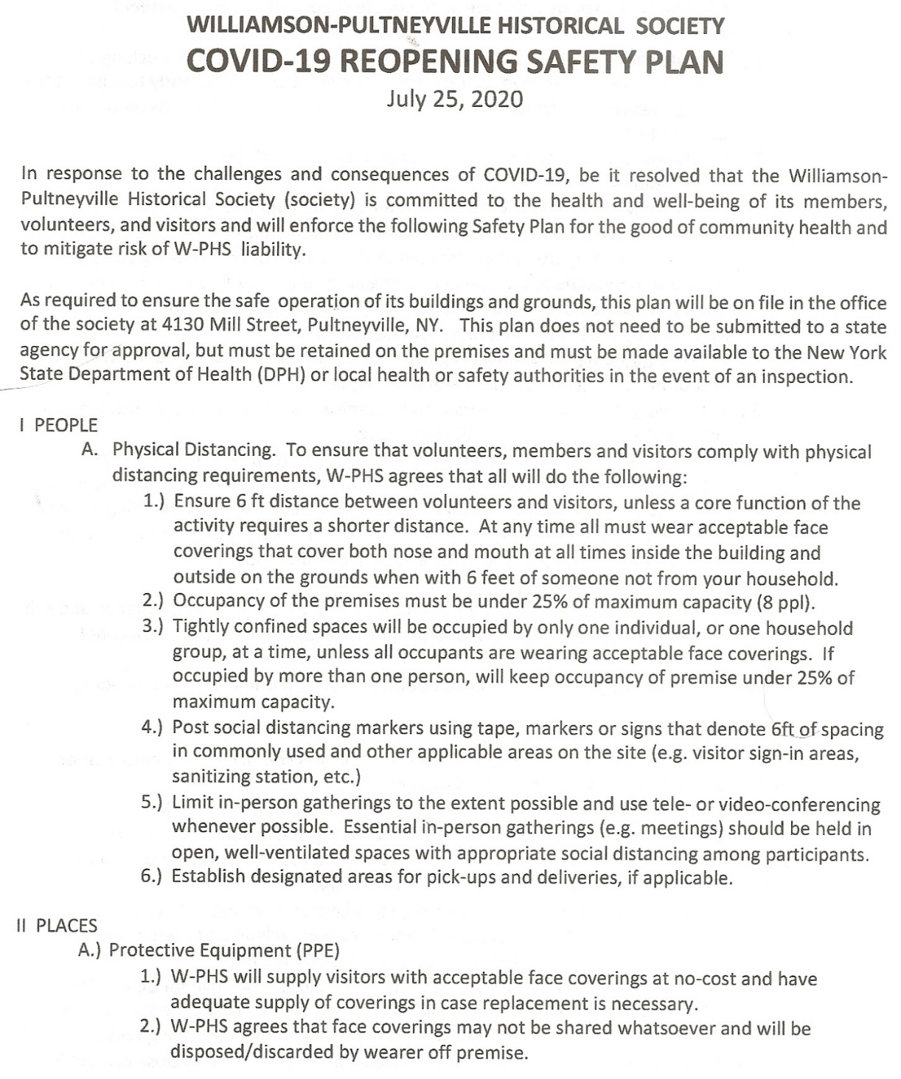

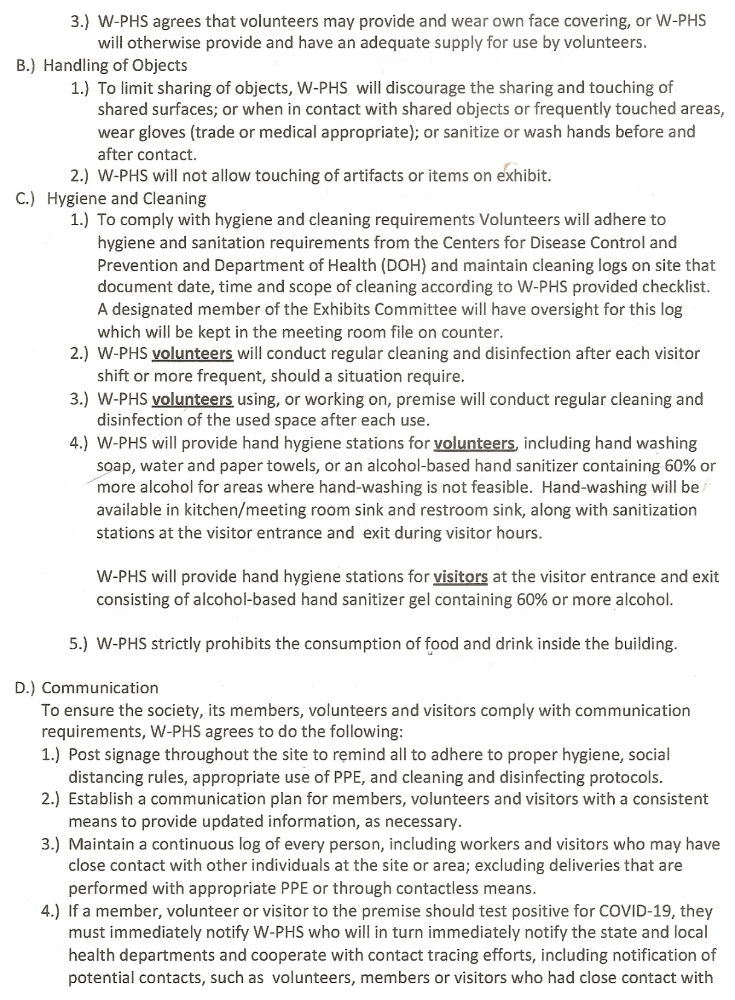

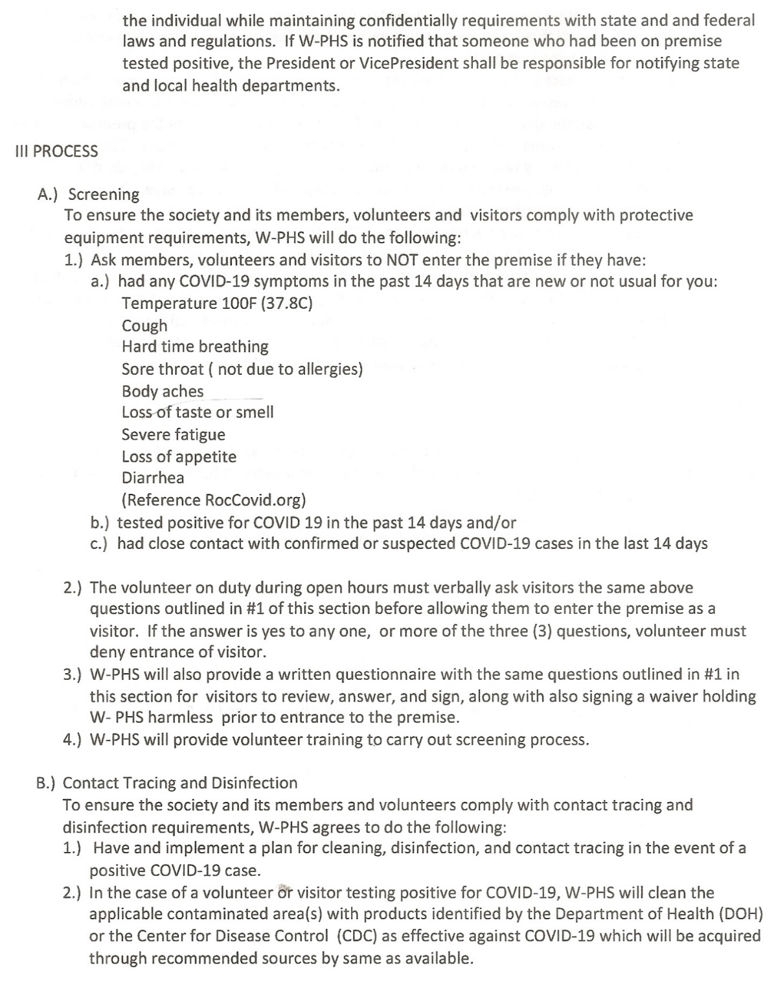

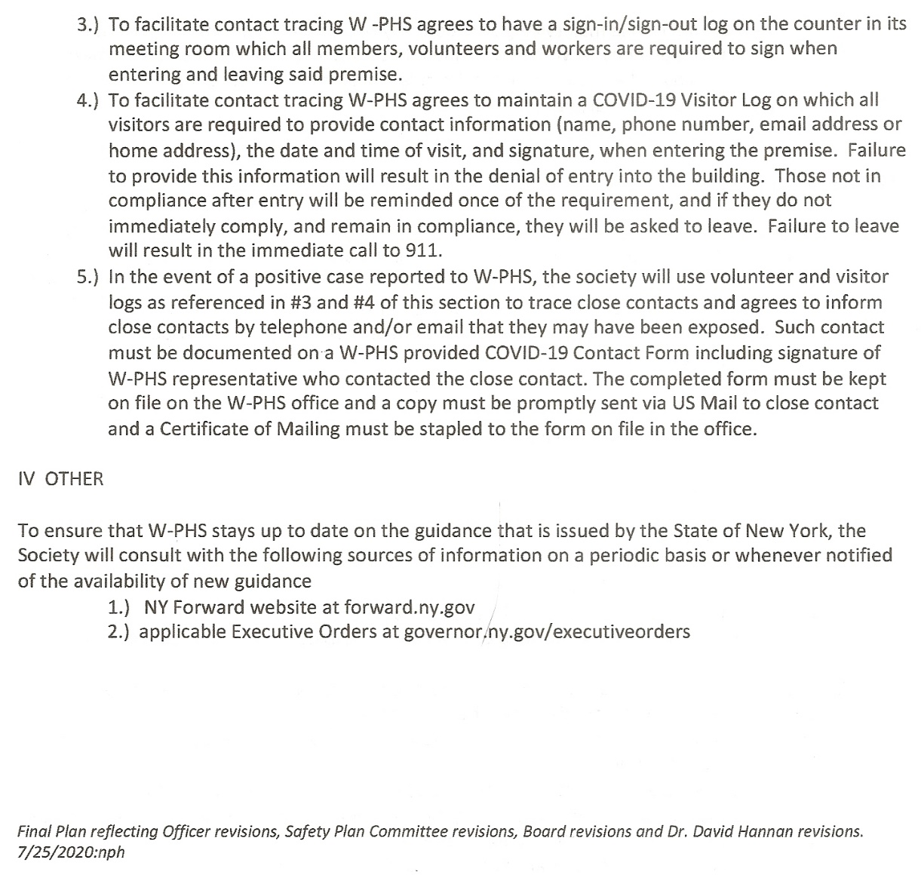

END OF SAFETY PLAN DISTRIBUTED

Volunteer of the Year Award- After discussion and in view of the Covid year where many activities were postponed, it was unanimously decided to not have the Volunteer of the Year Award this year.

Brass Plaques- Gary Buehler has requested the name of source for brass plaque for his house like other home have which were obtained through the Society. Next Steps- Linda to check with Betty Ann on year she purchased them from the Society; Cherie Kline to research newsletters in Archives the year they were offered and will check with Debbie to see if we can identify vendor payment.

Summary/Next Steps- Jackie summarized next steps.
Next Meeting- August 31, 2020 4pm Pavilion. Next Steps-Contact Karen Manahan re:Pavilion availability.
Adjournment- The meeting adjourned at 5:26pm on a motion by Cheryl and second by Florence with all in agreement.

Respectfully Submitted,

Jackie Walker, Recording Secretary
7/28/2020

